Seminar Report
Zhaokaitai JL20239070

Topic1--daily necessity desk lamp
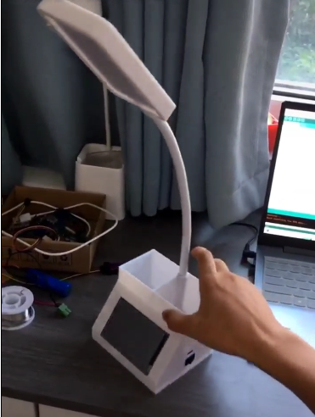
1.equipment and function
Desk lamp is an electrical appliance that we
often use in daily living. The following table
lamp is made by one of my classmate. He
designed this device and used it to participate
in the SPITP.He used USB to charge the
built-in 5V power. There is touchable panel so
that we can adjust brightness and show the time.
It can connect to the wireless network and
collect information . It also can be controlled
using app in your cell phone and use 64 LED
beads to achieve a rated power of 4W .
Figure 1.1
2.operating principle
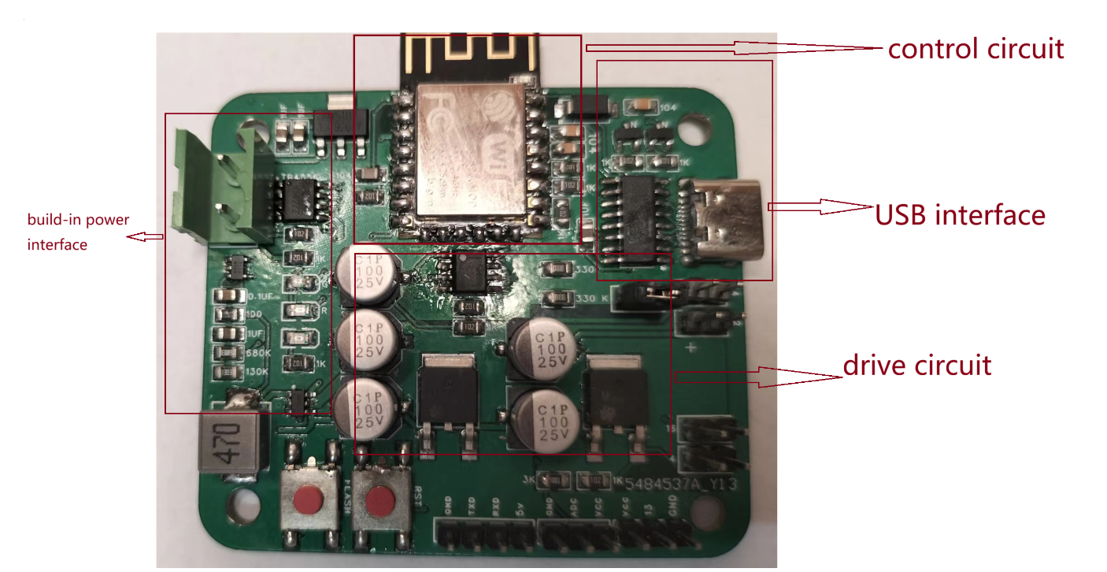
Figure 1.2
Its main working principle is as follows

Figure 1.3

The main control circuit generates PWM signals with different duty cycles. When the input duty cycle is higher, the brightness of the bulb will also be brighter.
3.power electronic device and component
Device | Model and specification | Function
control chip | ESP8266MOD | generate duty cycle
nMOS | NCE6050KA | switch
amplifier | LM358 | amplify the duty cycle
booster converter | PS7516 | amplify the voltage

Simulation Model
(Introduction to your models, e.g. “There are xxx characteristics to be specified and xxx model is established correspondingly.”, etc.)

2.1 (Simulation model 1)
(Detailed description of each model, e.g. “This model is established to find out the xxx characteristic of xxx device. It includes … When we have a source on xxx, we can get a curve of xxx”, etc.)

2.2 (model 2)
…

2.3 …
…

Parameter Setup

Simulation Results

Analysis of the Results

Tips:
Here is the recommended format of the report: The font used in the report is “Times New Roman”. The title and first-rank title are of size 11, bolded; second-rank titles are of size 11, inclined; and text is of size 10. You can adjust the margin by yourself to make your report neat. When you want to plug in figures, please place it in the center, and the description of the figure should be of size 8.

Figure 1: Logo of XJTU
Your report should include these five parts above. Do these by yourself and discuss with your group member(s) when you have questions.

